SCHOOL ATTENDANCE SYSTEM USING RFID

|  |  |  |
| --- | --- | --- |
| **BIL** | **NAME** | **MATRIC NO.** |
| 1 | ZIHNY FARHAN HAQEEM BIN ZAINI | 18DDT18F1040 |
| 2 | MUHAMMAD FARIS BIN ADNAN | 18DDT18F1109 |
| 3 | AHMAD AN NOOR BIN ABDUL NASIR | 18DDT18F1165 |

DEPARTMENT OF INFORMATION TECHNOLOGY AND COMMUNICATION

POLITEKNIK TUANKU SYED SIRAJUDDIN

JUNE 2020 SESSION

**ABSTRACT**

In traditional attendance system the teachers either call the name or Identity Number (ID) of the students to which student respond or pass the attendance sheet to the students to sign. The difficulty in such attendance management system increases when the number of students are increased. Also, in case of passing attendance sheet to the students, some student sign multiple times and the students give proxy attendance. To overcome these inconveniences, this project represents a school attendance system using RFID, which describes the Design and development of a wireless smart attendance system that will take an attendance by using information extracted from the database handling system. It is capable of collecting, recording and processing information on students of their activities, attendance or different sessions etc. The system can also generate real-time combined detailed reports on attendance, in time and out time of the students during the class hours. The implementation of the system is simple, inexpensive making it a good candidate for commercial and academic purpose.

**TABLE OF CONTENTS**

Abstract……………………………………………………………………………….2

Table of Figures………………………………………………………………………5

TableofTables.………………………………………………………………………..6

1.0 PROJECT PLAN…………………………………………………………………7

1.1 Introduction……………………………………………………………………….7

1.2 Problem Statement……………………………………………………………...7-8

1.3 Objective of Project…..…………………………………………………………..8

1.4 Scope of Project……………………………………...………………...................8

1.4.1 User Scope........……………………………………...…………………......…. 8

1.4.2 Function Scope..……………………………………...……………………........8

1.4.3 System Scope....……………………………………...………………………... 9

1.4.4 Location Scope…..…………………………………...……………..............…10

1.4.5 Software Scope.……………………………………...……………………......11

1.5 Literature Review……………………………………………………............11-16

1.6 Methodology of Project……………………………………………………........19

1.7 Project Gantt Chart………………………………………………………….......20

2.0 REQUIREMENT SPECIFICATION…………………………………..........….21

2.1 Functional Requirement…………………………………..............................21-22

2.2 Non Functional Requirement……………………………………………............23

2.3 Hardware and Software Requirement…………………………………………...23

2.4 System Configuration………………………………………………..............24-27

2.5 Security Requirement / Exceptional Handling…………………………...........

3.0 FINAL DESIGN...................................................................................................28

3.1 Logical Design………………………………………………………….........28-32

3.2 Physical Design………………………………………………………............

4.0 TEST DESCRIPTION AND RESULTS..............................................................33

4.1 Unit Testing Plan.....………………………………………………......……..33-34

4.2 Integration Testing Plan…....…………………………………………….......34-35

5.0 CONCLUSIONS AND RECOMMENDATIONS...............................................36

6.0 REFERENCE........................................................................................................37

**TABLE OF FIGURES**

Figure 1.1 : Block diagram of working system......................……………………..….9

Figure 1.2 Sekolah Kebangsaan Kuala Perlis…………………….............................10

Figure 1.3 View from Google Maps………………………………...........................10

Figure 1.4 Transpooler Attendance System................................................................13

Figure 1.5 BT Attendance System..............................................................................14

Figure 1.6 TEAMSPro Attendance System................................................................15

Figure 1.7 : Rapid Application Development.............................................................18

Figure 2.1 : Connection between Arduino Uno and RFID........................................25

Figure 2.2: steps of Nodemcu on Arduino IDE..........................................................26

Figure 2.3: ESP8266 Board Package..........................................................................27

Figure 2.4: ESP8266 Support.....................................................................................28

**TABLE OF TABLES**

Table 1.1: Software scope.....................................................…………….......……...11

Table 1.2 : Table Comparison.....................................................................................16

Table 2.1 : Attendance Management System Functional Requirements....................21

Table 2.2: Functional Requirements for Web Application.........................................22

Table 2.3 : Non Functional Requirement....................................................................23

Table 2.4 : Hardware and Software Requirement.......................................................23

Table 4.1 Web System Unit Testing Plan (UTP)........................................................33

Table 4.2 School Attendance System using RFID Unit Testing Plan (UTP).............34

Table 4.3 Web System Integration Testing Plan (ITP)...............................................34

Table 4.4 School Attendance System Integration Testing Plan (ITP)........................35

**CHAPTER 1**

**1.0 PROJECT PLAN**

* 1. **Introduction**

School Attendance System Using RFID is a digital attendance system which uses Radio Frequency Identification (RFID) in order to record the presence of students in class. RFID is chosen because this application is widely used in all over the world and by applying this system, it may shorten the time compared to the current method which records the student attendance manually. Instead of using the manual method where students need to write their name manually, they can just touch their RFID Cards on card reader in order to record their attendance in class.

Hence a system is needed which will solve the issue of manual attendance.So, we as a group came up with a idea to created and conduct a system called “School Attendance System Using RFID”.This project attempts to record student’s attendance through RFID. School Attendance System Using RFID is an application developed to record daily student’s attendance in the targeted school that is Sekolah Kebangsaan Kuala Perlis or its short name SK Kuala Perlis, is a primary school located at Jalan Kuala Perlis.

Students need to scan their RFID card in front of class door. Once the RFID Card and reader have been scanned, information regarding the student’s name will be displayed on the LCD screen to verify their attendance in class.Then, Arduino will receive the student data details and send it to the database.Teacher can login to the web application to check the students attendance details.

* 1. **Problem Statement**

The major problem that faced by this School is they are still record student’s attendance by manually system.The existing system largely consists of physical register where the teacher have to manually inputs the attendance record of all students one by one.Teacher always have to call the name of every students one by one to verify their attendance to be tick it right on the attendance book record.This will take some time for the teacher to start teaching

The traditional way for taking attendance has drawback, which is the data of the attendance list cannot be reuse and tracking and tracing student's attendance is harder.Besides, the paper may be torn, misplaced or lost for recording in database system manually.With the RFID-based system, all data will be secured and stored in database safely.

The teachers of Sekolah Kebangsaan Kuala Perlis have to come to class every morning to get the total attendance of their class everyday.The class teachers also need to call the teacher that incharge for the first subject to get attendance if they do not want to come to class in the morning. It make the teacher to waste their time to come to class or call first time subject teachers.

* 1. **Objective of Project**

The main objectives of School Attendance System Using RFID are:

* To record Student attendance
* To view and generate student attendance report
* Manage or assign teachers and students information

**1.4 Scope of Project**

There are types of scope such as user scope,function scope,system scope and location scope.Below is the explanation for four scopes.

* + 1. **User Scope**

1. Admin

The managing director of the company is the admin of the system. In this system, the admin of the company is able to update user of the system and view all update record and slots in Attendance System are done.

1. Teachers

Teachers can update students attendance records, remove students attendance records, view students record lists and can print attendance record lists.

1. Students

Students need to touch their RFID card at the scanner and view their name displayed at the lcd screen.

* + 1. **Function Scope**

System to make it easier for teachers to record and view daily student attendance for more systematically rather than the traditional way.

* + 1. **System Scope**

Our project is a web-based application. All information is store in server. RFID tag tracked by RFID reader. RFID reader has a power and is a network-connected device that sends data and commands to the tags. RFID reader process like an access point for RFID tagged sections. The RFID reader reads the student’s ID by using reading process and Arduino IDE passes student’s information to the XAMPP server through the router via Wi-Fi that is a transmission process. Server (MySQL and PHP) is use to identify student ID and to send student’s information to the database. The student touches the RFID tag to the RFID reader where RFID reader reads student’s ID, then send it through Nodemcu. On the server side (MySQL and PHP) where it searches Student’s ID in central server database then the information can show on the website.

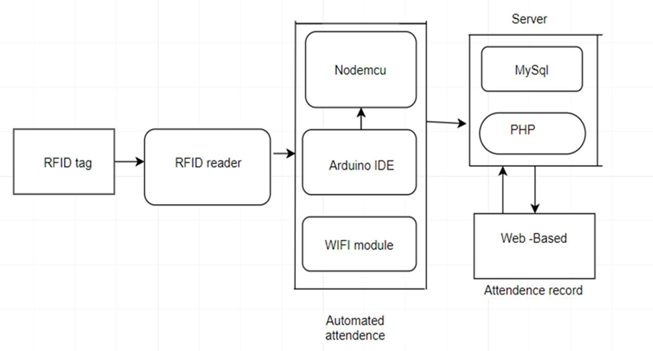

Figure 1.1 : Block diagram of working system

* + 1. **Location Scope**

This system will implement at Sekolah Kebangsaan Kuala Perlis.The address of School is 32, Jalan Besar, Pekan Kuala Perlis, 02000 Kuala Perlis, Perlis.

Figure 1.1 and Figure 1.2 shows picture of the school and the view from the Google Maps of Sekolah Kebangsaan Kuala Perlis.

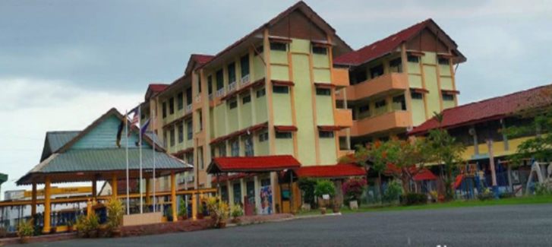

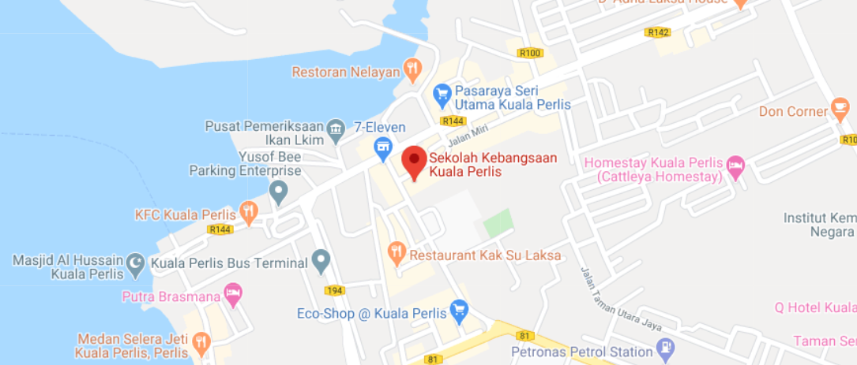Figure 1.2 Sekolah Kebangsaan Kuala Perlis

Figure 1.3 View from Google Maps

* + 1. **Software Scope**

To produce this system, there are some software used as in the table 1 below:

Table 1.1: Software scope

|  |  |
| --- | --- |
| **Software** | **Explanation** |
| Arduino IDE | To produce this system |
| Notepad++ | To produce web based application |
| MySQL | Store and sync data in real time |
| Microsoft Word | To produce the proposal or report of the system |

**1.5 Literature Review**

The main purpose of the literature review is to study the problem and assess the existing system, or any activity related to the projects to be developed. Collect information about the system, the system requirements and priority system should also be investigated. An interview with teachers of Sekolah Kebangsaan Kuala Perlis has done to collect information and to understand the user’s requirements. Knowledge regarding to the inventory information also can be collected from observation session and interview. It will be easier for programmer to develop School Attendance System using RFID.

Sekolah Kebangsaan Kuala Perlis does not exist any attendance system, so attendance on the paper for pupils attendance is the only method used for teachers to record all the attendance and pupils information.

Moreover, comparison between existing systems in market also helps the developer to get some idea to determine the functions in new system. The information from research are very useful in develop School Attendance System using RFID as well as to solve the problem faced by the users which are administrator, teachers and the students.

In this project, the literature review will be used as a guideline during the development process. Besides that, the literature review also can help the developer to build up the system more effective.

Furthermore, the study of literature is important in developing a project. It is done to collect various information related to the project in which this information will serve as guidelines and provide a clear picture of the project to be develop.

**1.5.1 Attendance**

Attendance is the concept of people, individually or as a group, appearing at a location for a previously scheduled event. Measuring attendance is a significant concern for many organizations, which can use such information to gauge the effectiveness of their efforts and to plan for future efforts.

in both classroom settings and workplaces, attendance may be mandatory. Poor attendance by a student in a class may affect their grades or other evaluations. Poor attendance may also reflect problems in a student's personal situation, and is an indicator that "students are not developing the knowledge and skills needed for later success".

For students in elementary school and high school, laws may require compulsory attendance, while students at higher levels of education may be penalized by professors or the institution for lack of attendance.

**1.5.2 Radio Frequency Identification (RFID)**

Radio-frequency identification (RFID) uses electromagnetic fields to automatically identify and track tags attached to objects. An RFID tag consists of a tiny radio transponder; a radio receiver and transmitter. When triggered by an electromagnetic interrogation pulse from a nearby RFID reader device, the tag transmits digital data, usually an identifying inventory number, back to the reader. This number can be used to inventory goods. There are two types. Passive tags are powered by energy from the RFID reader's interrogating radio waves. Active tags are powered by a battery and thus can be read at a greater range from the RFID reader; up to hundreds of meters. Unlike a barcode, the tag doesn't need to be within the line of sight of the reader, so it may be embedded in the tracked object. RFID is one method of automatic identification and data capture (AIDC).

**1.5.3 Mobile App**

A mobile app is a software application developed specifically for use on small, wireless computing devices, such as smartphones and tablets, rather than desktop or laptop computers.

Mobile apps are designed with consideration for the demands and constraints of the devices and also to take advantage of any specialized capabilities they have. A gaming app, for example, might take advantage of the iPhone's accelerometer.

Mobile apps are sometimes categorized according to whether they are web-based or native apps, which are created specifically for a given platform. A third category, hybrid apps, combines elements of both native and Web apps. As the technologies mature, it's expected that mobile application development efforts will focus on the creation of browser-based, device-agnostic Web applications.

**1.5.4 System Comparison**

1. **First System : Transpooler Attendance System**

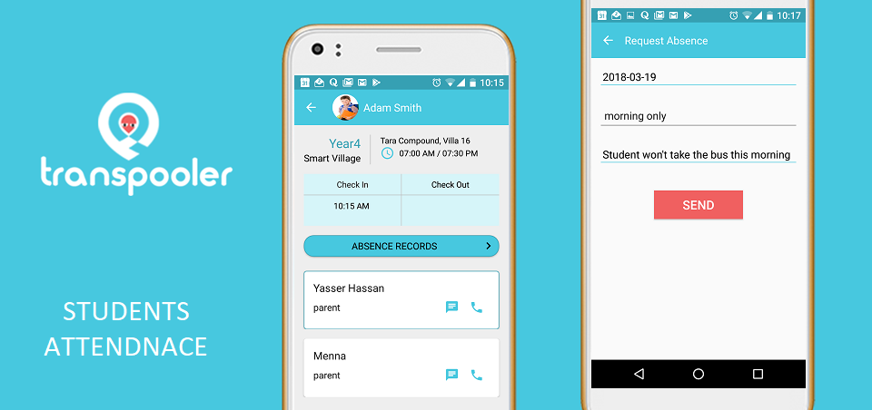

Figure 1.4 Transpooler Attendance System

Transpooler Attendance System was specially developed to help the administrator to manage attendance easily and accurately in accordance with the format and guidelines laid down by the company. Through this application users can perform functions as follow to count the amount of order based on their position in the company.

1. **Second System : BT Attendance System**

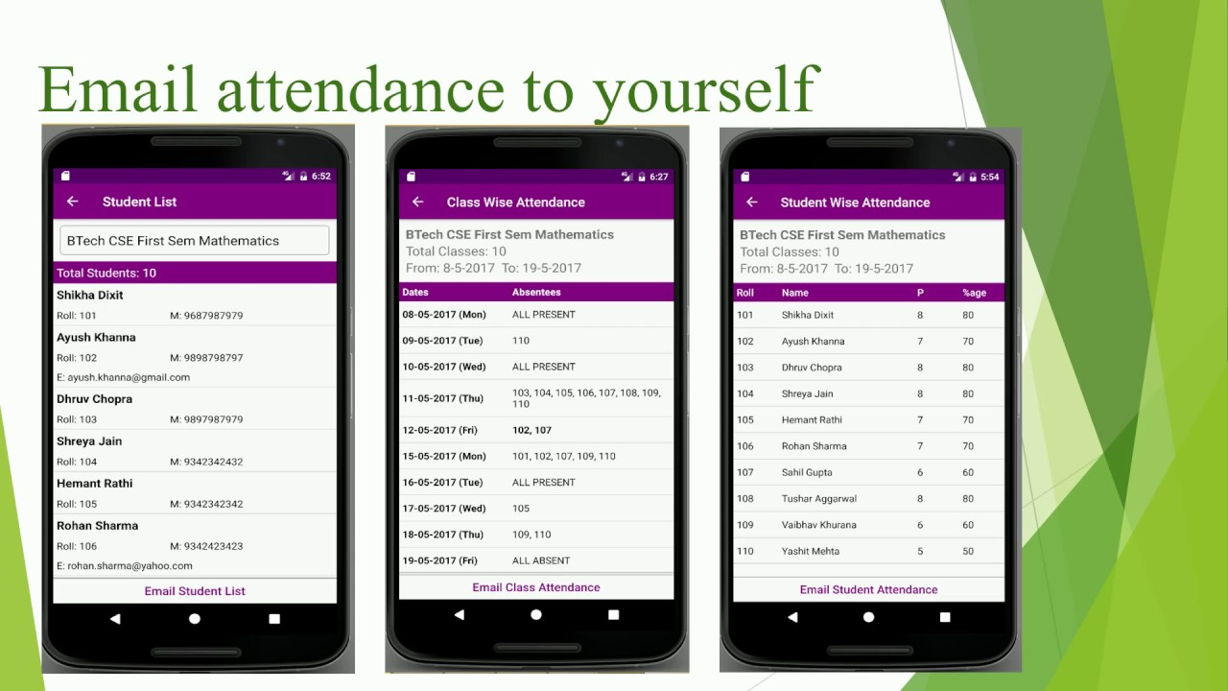

Figure 1.5 BT Attendance System

BT Attendance System was developed to help the production for storing information about the pupils attendance accurately. Through this system the production can add pupils information easily. This system is also enable the teacher to search for the attendance classes and then can print it out.

1. **Third System : TEAMSPro Attendance System**

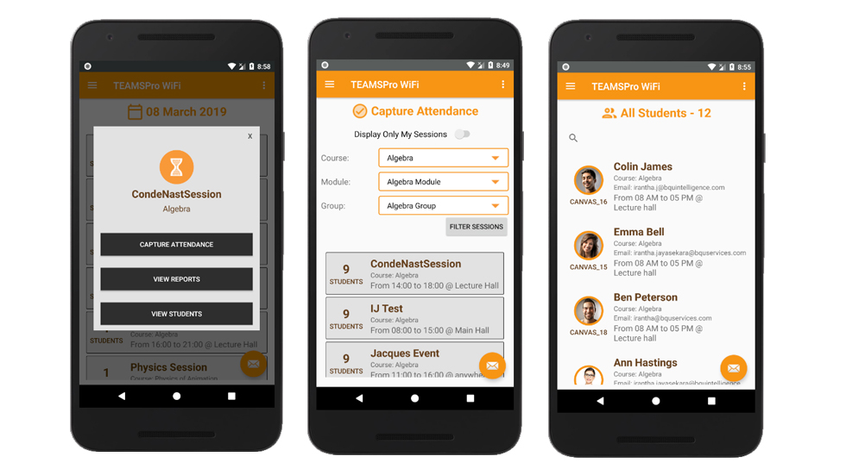

Figure 1.6 TEAMSPro Attendance System

​ TEAMSPro Attendance System consists of students details, classroom details, lecturer details as well as attendance details. The app communicates with the Central database via the API. I was responsible for the API as well which is developed

This system requires the app to be installed on the lecturer phone. When the lecture come to the class he will run the app and will ask for students to turn on Bluetooth or wifi on their phones. When students turn on, lecturer phon's app will start to identify available devices and synchronise with the central database. This process is ideal to identify the presence of a person over time. The application developed with JAVA in Android Studio studio environment.

|  |  |  |  |  |  |
| --- | --- | --- | --- | --- | --- |
| **CRITERIA** | | **DETAIL** | | |  |
|  | | **Transpooler Attendance System** | **BT Attendance System** | **TEAMSPro Attendance System** | **School Attendance System Using RFID** |
| Platforms  Supported | RFID | No | No | No | Yes |
| Windows Phone App | Yes | No | No | Yes |
| Typical Customers | Small business | Yes | Yes | Yes | Yes |
| Mid Size Businesses | Yes | Yes | Yes | Yes |
| Large Enterprise | Yes | Yes | No | Yes |
| Customer  Support | Phone | No | No | Yes | Yes |
| Online | Yes | Yes | Yes | Yes |
| Knowledge base | Yes | Yes | No | Yes |
| Video Tutorials | Yes | Yes | No | Yes |
| Security | Encryption of sensitive data at rest | No | No | Yes | Yes |
| HTTPS for all pages (web-based apps) | No | Yes | Yes | Yes |
| Database | |  |  |  | MySQL |

Table 1.2 : Table Comparison

**1.6 Methodology of Project**

**1.6.1 Introduction**

The term software development methodology is used to describe a framework for the development of information systems. A particular methodology is usually associated with a specific set of tools, models and methods that are used for the analysis, design and implementation of information systems, and each tends to favor a particular lifecycle model. Often, a methodology has its own philosophy of system development that practitioners are encouraged to adopt, as well as its own system of recording and documenting the development process. Many methodologies have emerged in the past few decades in response to the perceived need to manage different types of project using different tools and methods. Each methodology has its own strengths and weaknesses, and the choice of which approach to use for a given project will depend on the scale of the project, the nature of the business environment, and the type of system being developed.

**1.6.2 Rapid Application Development(RAD)**

Starting with the ideas of Barry Boehm and others, James Martin developed the rapid application development approach during the 1980s at IBM and finally formalized it by publishing a book in 1991, Rapid Application Development. This has resulted in some confusion over the term RAD even among IT professionals. It is important to distinguish between RAD as a general alternative to the waterfall model and RAD as the specific method created by Martin. The Martin method was tailored toward knowledge intensive and UI intensive business systems.

These ideas were further developed and improved upon by RAD pioneers like James Kerr and Richard Hunter, who together wrote the seminal book on the subject, Inside RAD, which followed the journey of a RAD project manager as he drove and refined the RAD Methodology in real-time on an actual RAD project. These practitioners, and those like them, helped RAD gain popularity as an alternative to traditional system project life cycle approaches.

Rapid Application Development (RAD) is a form of agile software development methodology that prioritizes rapid prototype releases and iterations. Unlike the Waterfall method, RAD emphasizes the use of software and user feedback over strict planning and requirements recording.

Some of the key benefits and advantages of RAD are:

• Enhanced flexibility and adaptability as developers can make adjustment quickly during the development process.

• Quick iterations that reduce development time and speed up delivery.

• Encouragement of code reuse, which means less manual coding, less room for errors, and shorter testing times.

• Increased customer satisfaction due to high-level collaboration and coordination between stakeholders (developers, clients, and end users).

• Better risk management as stakeholders can discuss and address code vulnerabilities while keeping development processes going.

• Fewer surprises as, unlike the Waterfall method, RAD includes integrations early on in the software development process.

Figure 1.7 shows the phase involved in RAD

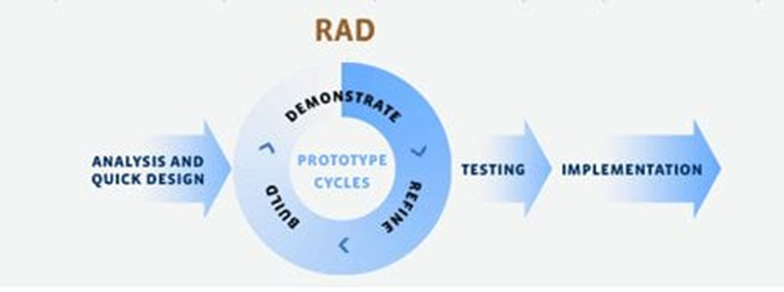

Figure 1.7 : Rapid Application Development.

**1.6.3 Rapid Application Phase**

Phase 1 – Analysis

In this analysis phase, we choose a company for the project at Kuala Perlis, Perlis. We were contact the company by mobile phone which were call and WhatsApp, interview the person in charge of the company. Lastly, list the current problem and find requirement of system.

Phase 2 – Design

In this design phase, create use case diagram to show the functionality of system, create Entity Relationship Diagram (ERD) to represent the data in database, create Data Flow Diagram to show the data flow involved in the system, create context diagram, create storyboard of interface and create interface of system.

Phase 3 – Development

In this development phase, we create procedure manuals, create system, create database, create connection database and get feedback from the person in charge.

Phase 4 – Refine

In this refine phase, updating whether the error connection if any and make changes to that it fits with the environment in location that is use.

Phase 5 – Testing

In this phase, will test database and developed a program to access the system built. The system will be accessed whether it can operate perfectly or no. The system will be tested to determine if there is any error in system developed.

Phase 6 – Implementation

In this implementation phase, will develop and testing out new system and mobile application. Then, will create a system that can be used by the use tools. It involves writing a program and documentation when the system is successfully developed.

**1.7 Project Gantt Chart**

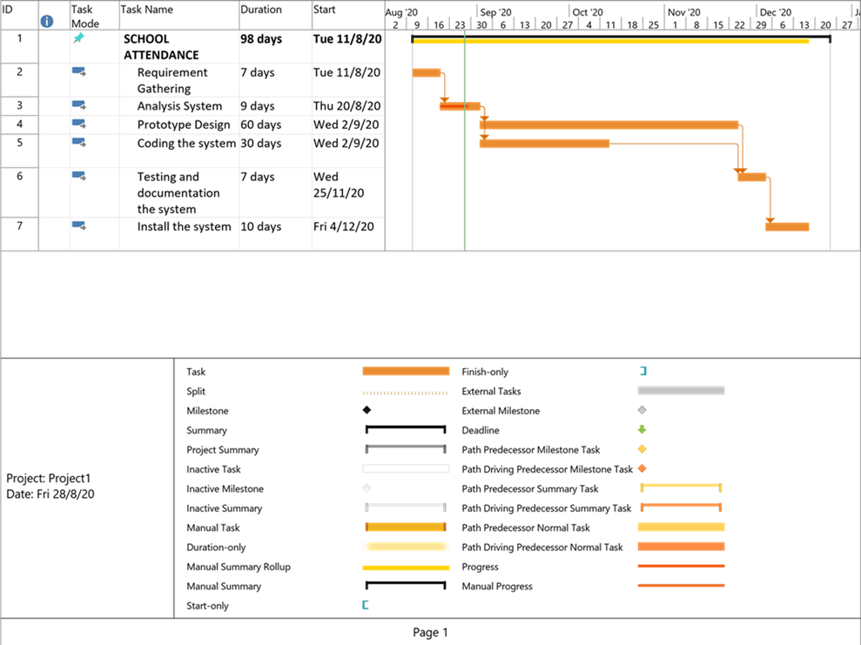

**CHAPTER 2**

**2.0 REQUIREMENT SPECIFICATION**

**2.1 Functional Requirements**

The attendance management system to be developed is expected to facilitate the process of recording attendance through Web Based Application and RFID.The table 2.1 and 2.2 below shows the functional requirements for the Attendance management system and Web application respectively.

Table 2.1 : Attendance Management System Functional Requirements

|  |  |  |
| --- | --- | --- |
| **ACTORS** | **REQUIREMENT** | **DESCRIPTION** |
| RFID Reader | Record Attendance | RFID reader will be recording the attendance by detecting the Tags attached by students. |
| Class Teacher | Login  View Attendance  Edit Student  Register Student | Class teacher will login into the system and upon successful, he/she will be able to view attendance information, Edit student details and Register new students. |
| Head Master (Admin) | Login  View Attendance  Edit Student  Register Student  Delete Student | The Head Master will login into the system, view attendance, Edit students, Register Students and Delete Students. |

Table 2.2: Functional Requirements for Web Application

|  |  |  |
| --- | --- | --- |
| **ACTORS** | **REQUIREMENT** | **DESCRIPTION** |
| Class Teacher | * Take attendance * View attendance * Upload attendance * Login | * The class teacher/master is required to be able to take student attendance and upload to the back end database in case the RFID part is not working or not deployed. * The class teacher/master should be able to view student attendance for different interval of time. |
| Head Teacher (Admin) | * Edit student * Register student * Delete student * View attendance * Login | * The head Master/Teacher monitors the registered students and their attendance.She/he is also responsible for registering or deleting student. |

**2.2 Non Functional Requirement**

These are constraints on the operation of the system that are not related directly to a function of the system.

Table 2.3 : Non Functional Requirement

|  |  |  |
| --- | --- | --- |
| **No.** | **REQUIREMENT** | **DESCRIPTION** |
| 1 | Operability | * The Web application will be developed under PHP platform. * The application will run on Laptop/PC or Smartphone. |
| 2 | Maintainability | * The application is Specifically for Laptop/PC and Smartphone. |
| 3 | Security | * The system shall provide access to only registered users. The authorized users will login to the application |
| 4 | Performance | * The application will process attendance information as faster as possible from the moment of submission. |

**2.3 Hardware and Software Requirement**

Table 2.4 : Hardware and Software Requirement

|  |  |  |
| --- | --- | --- |
| **Bil** | **Hardware** | **Software** |
| 1 | NodeMcu ESP8266 | Arduino IDE |
| 2 | RFID-RC522 Module | XAMPP server |
| 3 | Jumper Wires | PHP Source Code |
| 4 | Micro USB Cable | RFID-RC522 Library |
| 5 | Mini Breadboard | NodeMcu ESP8266 Library and Board Manager |
| 6 | LCD Display | Notepad++ |

**2.4 System Configuration**

**2.4.1 Connection between NodeMCU and RFID**

We will assemble the base configuration following the circuit’s diagram show below. Then, we connect NodeMCU and open the Arduino IDE and given the code.

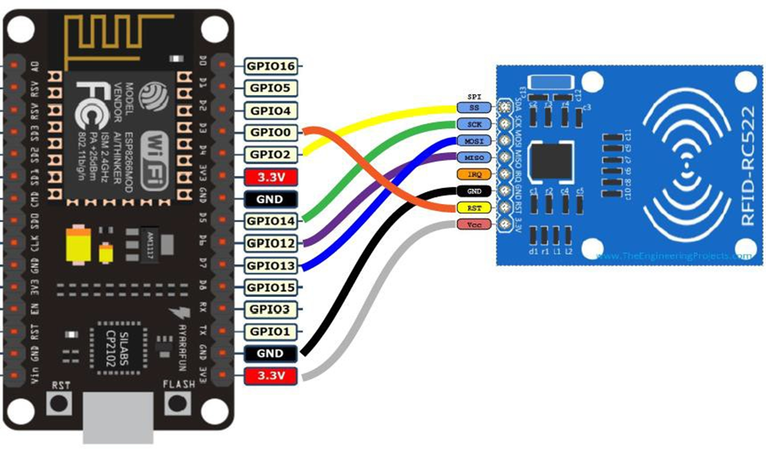

Figure 2.1 : Connection between NodeMCU and RFID

**2.4.2 Connection between Arduino IDE and NodeMCU**

There are six steps to connect Nodemcu on Arduino IDE.



**Step 3: Install the Arduino IDE 1.6.4 or Greater**

**Step 2: Install the COM/Serial Port Driver**

**Step 1: Connect NodeMCU to the Computer**



**Step 4: Install the ESP8266Board Package**

**Step 5: Setup ESP8266 Support**

Figure 2.2: steps of Nodemcu on Arduino IDE

Step 1: Connect NodeMCU to the Computer

We are use the cable connect nodeMCU to the computer, we will see the blue onboard LED flicker when powered up, but they will not stay lit.

Step 2: Install the COM/Serial Port Driver

That one may transfer code to the ESP8266 and adoption the serial console, attach any data- capable micro usb cable to ESP8266 IoT board and the other side to our computer’s usb port. The new version NodeMCUv3.0 appears with the CP2102 serial chip, we can download and install the driver from www.silabs.com/products/development-tools The NodeMCUv0.9 appears with the CH340 serial chip; we can download and install the driver from github.com/nodemcu/nodemcu-devkit/tree/mas

Step 3: Install the Arduino IDE 1.6.4 or Greater

Download Arduino IDE from Arduino.cc (1.6.4 or greater). We can use our existing IDE if we have already installed it. We can also try downloading the ready-to-go package from the ESP8266-Arduino project, if the proxy is giving our problems.

Step 4: Install the ESP8266 Board Package

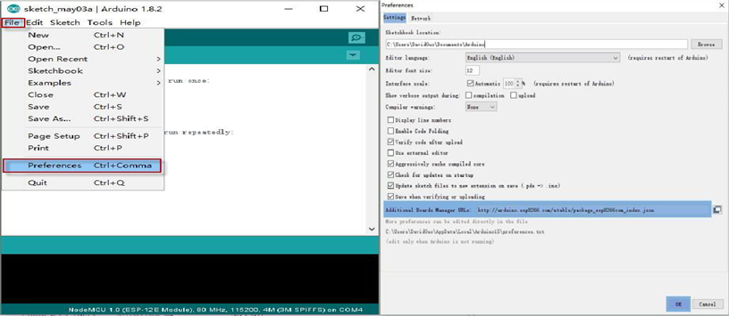

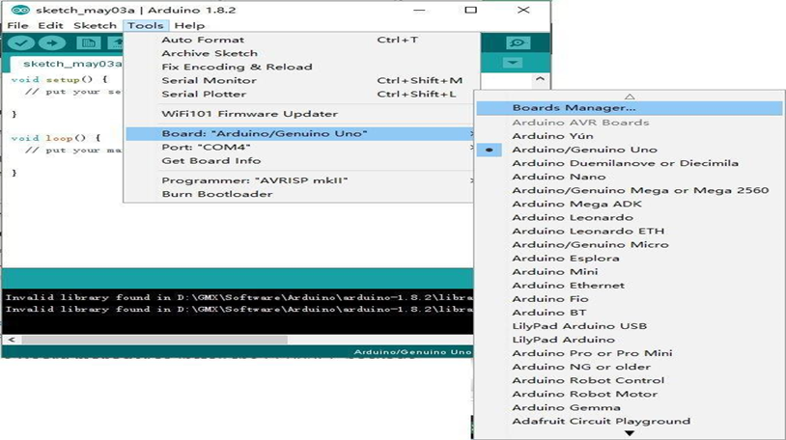

Figure 2.3: ESP8266 Board Package

Step 5: Setup ESP8266 Support

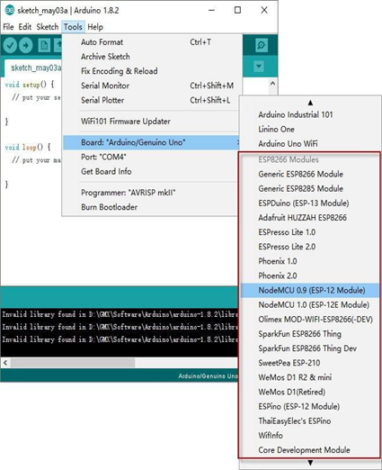

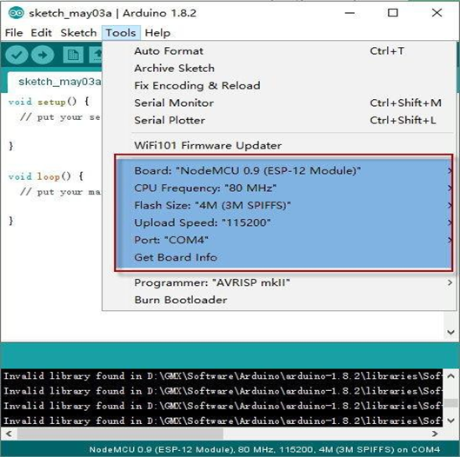

Figure 2. 4: Setup ESP8266 Support

**2.5 Security Requirement**

2.5.1 The Current System Security

The current system, which is Canvas, has its policy on its site page. The current system builds upon a user name and password access. Admin and Teacher can access to his/her account through their page, and they can control it.

**2.5.2 User Access**

Inside the community, there are students, teachers, and admin who are going to use the system. The main actor of the users in the entity is teachers and admin. Students will use the entity everyday by scanning their rfid tags by the beginning of each class. Teachers will use the system through Web based application, and they can access to student attendance record. Admin will use the entity to view attendance, Edit students, Register Students and Delete Students. Teachers is able to view attendance information, Edit student details and Register new students.Furthermore, admin will check on every student’s identification for security purposes. They check on students for identification in person before they add, edit, update and delete any information from their rfid tags id records in the system. Admin will ask students for ID for identification and scan their rfid tags in the device if needed to make sure the person is identified.

**2.5.3 Threats to the system security**

This system may face many threats. Sometimes, it comes from a community insider. This could be someone who discloses the data form the database where it located. Another type of deception is false identification, such as a fake ID, when students present for the registration .The system will reduce this kind of misuse because the rfid tags scanning is more secure than others. Each of rfid tags has unique. However, admin who in charge the registration should check on the identification carefully before initiating any processes in the system. These records will be the official record for all students, since they begin school and until they graduate.

**2.5.4 Levels of security:**

1) Hardware: The RFID scanner devices must be located in a secure location.

2) The network:

3) The data management system:

1. Students can access to their classes to the system check by RFID.

2. Admin and Teacher would be the same as we have now, and they will control the attendance page/report.

3. The purpose of the registration office is to make sure every student has the right rfid tags id record and right information in the system on a consistent basis.

**2.5.4 Level of access**

Subject:

People level:

1) Users (students).

2) Teachers (Control on Attendance section).

3) Admin (control the system).

Computer level:

1) Hardware (RFID reader)

2) Software (the system)

**CHAPTER 3**

**3.0 FINAL DESIGN**

**3.1 Logical Design**

i) Data Flow Diagram

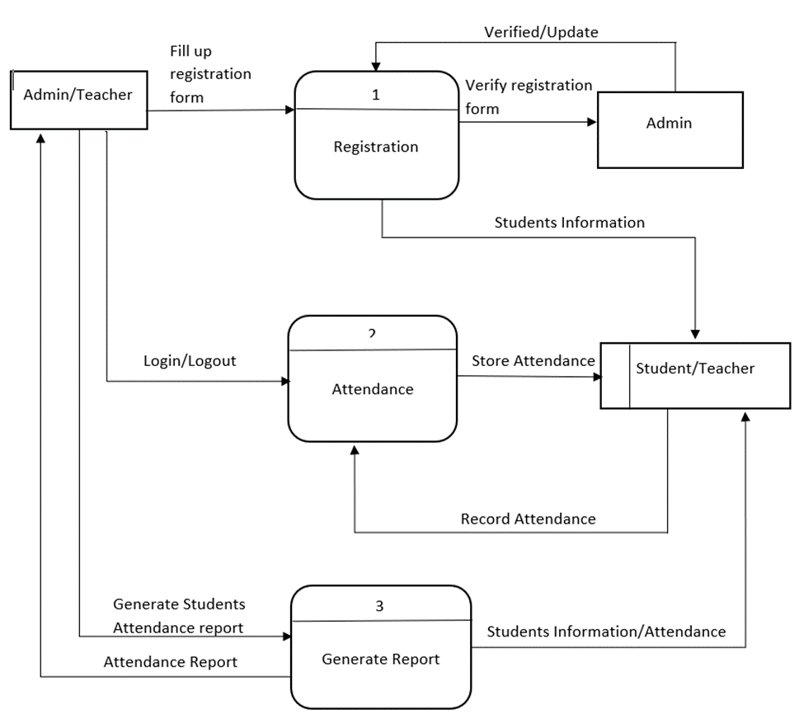

2) Flow Chart

Yes

No

Database

Student Info and Class

Student Attendance registered

Attendance Processing

Match?

Scan RFID from scanner

Input RFID code and Student Information

3) Entity Relationship diagram

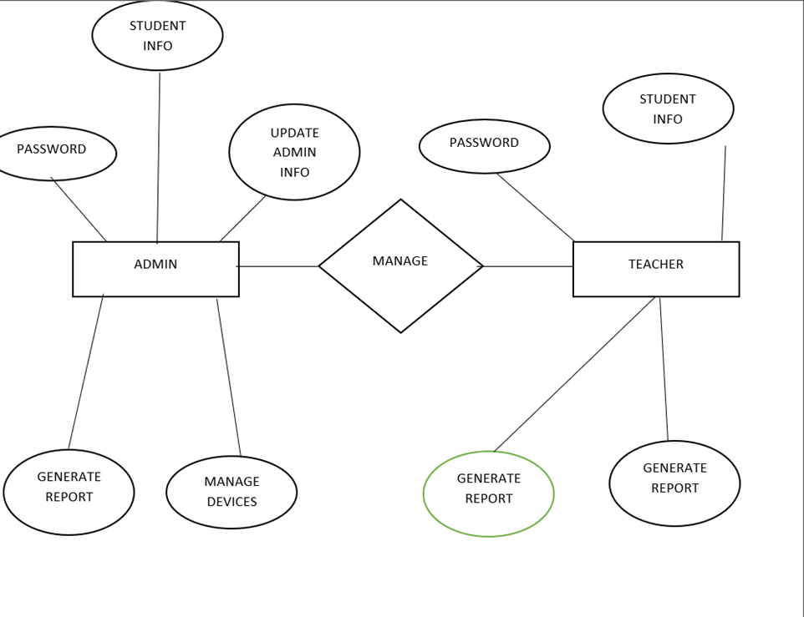

4) Context Diagram

REGISTER NEW STUDENTS

0

SCAN RFID

VIEW STUDENTS INFORMATION

LOGIN

REGISTER STUDENTS

VIEW STUDENTS ATTENDANCE

LOGIN

ADMIN

ATTENDANCE SYSTEM

TEACHER

STUDENT

**3.2 Physical Design**

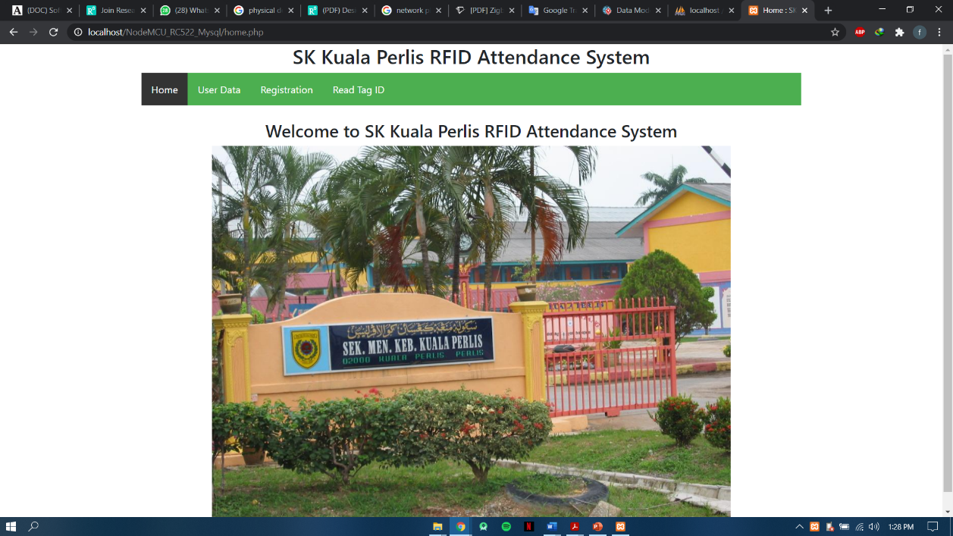

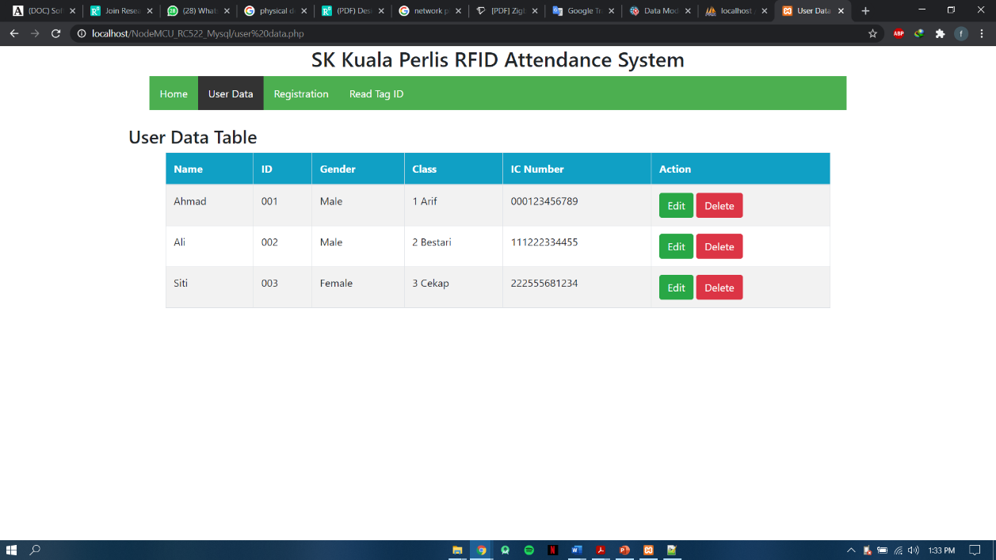

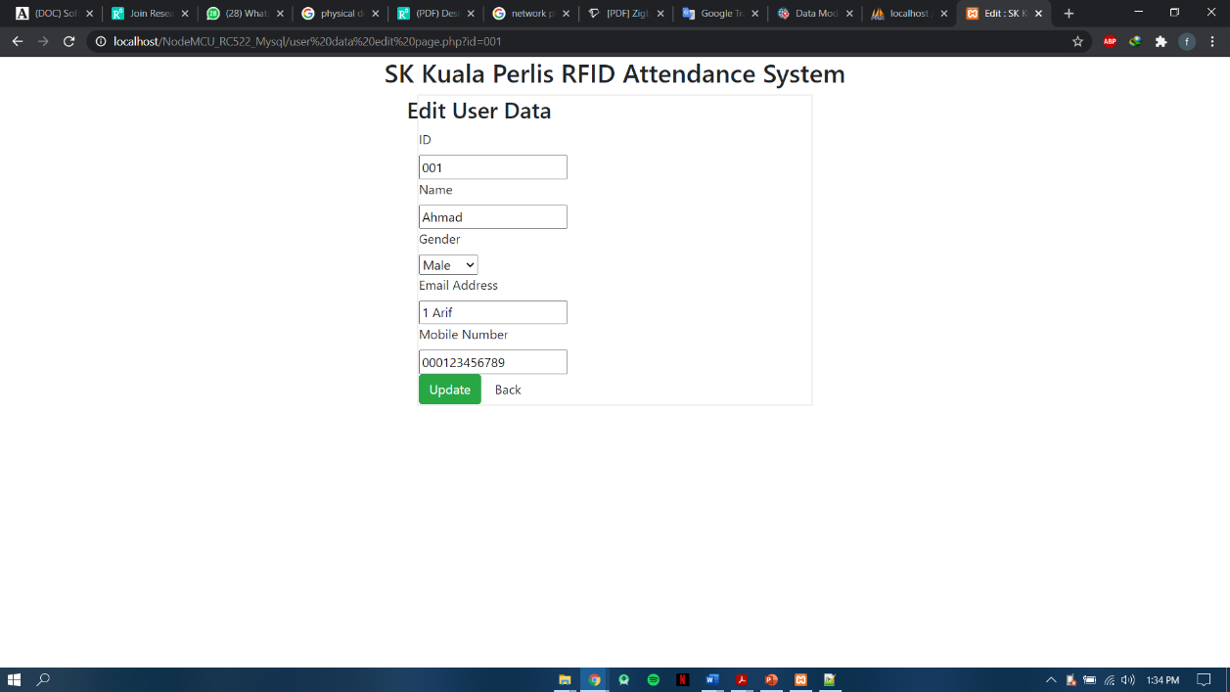

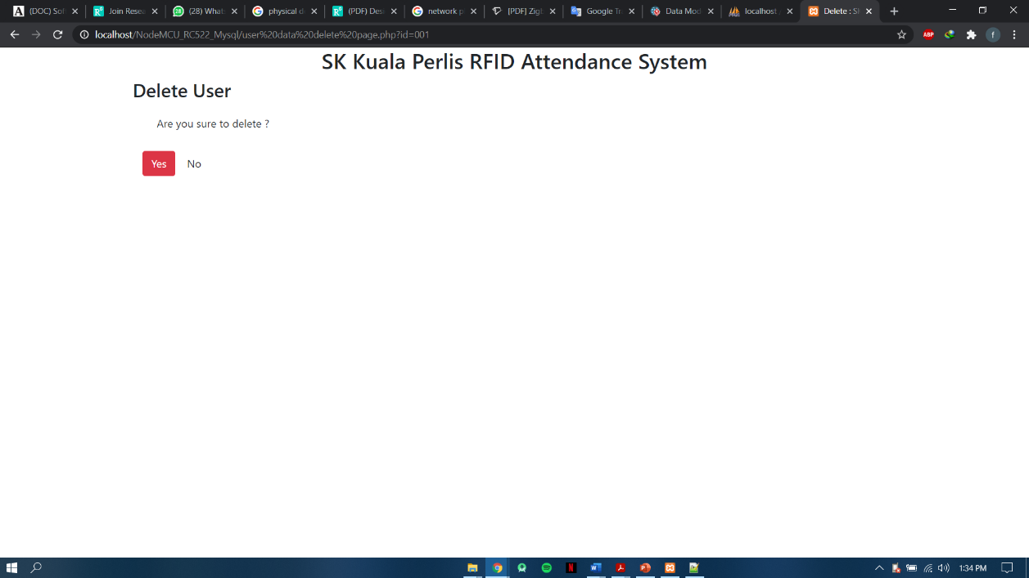

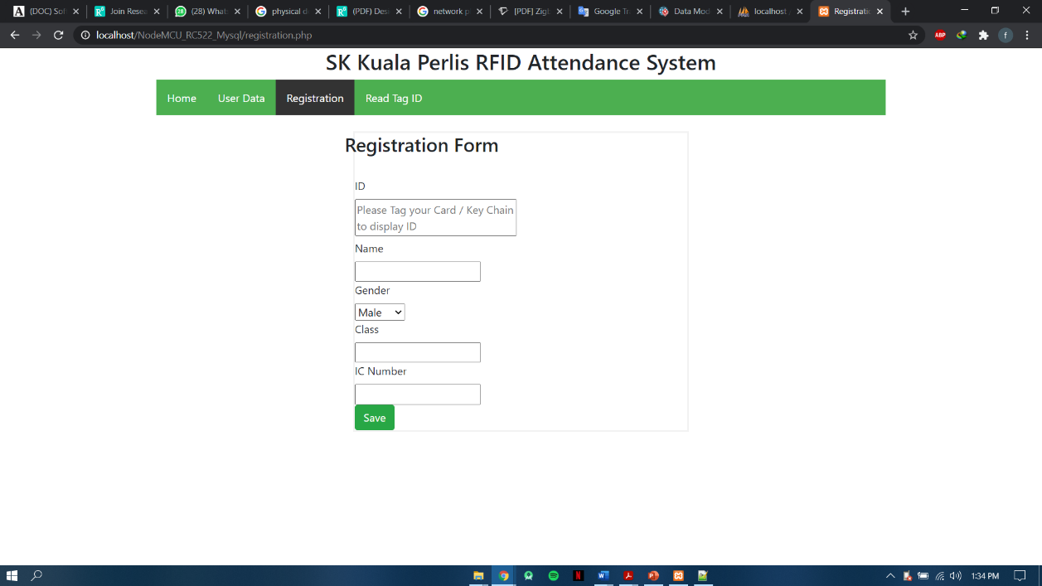

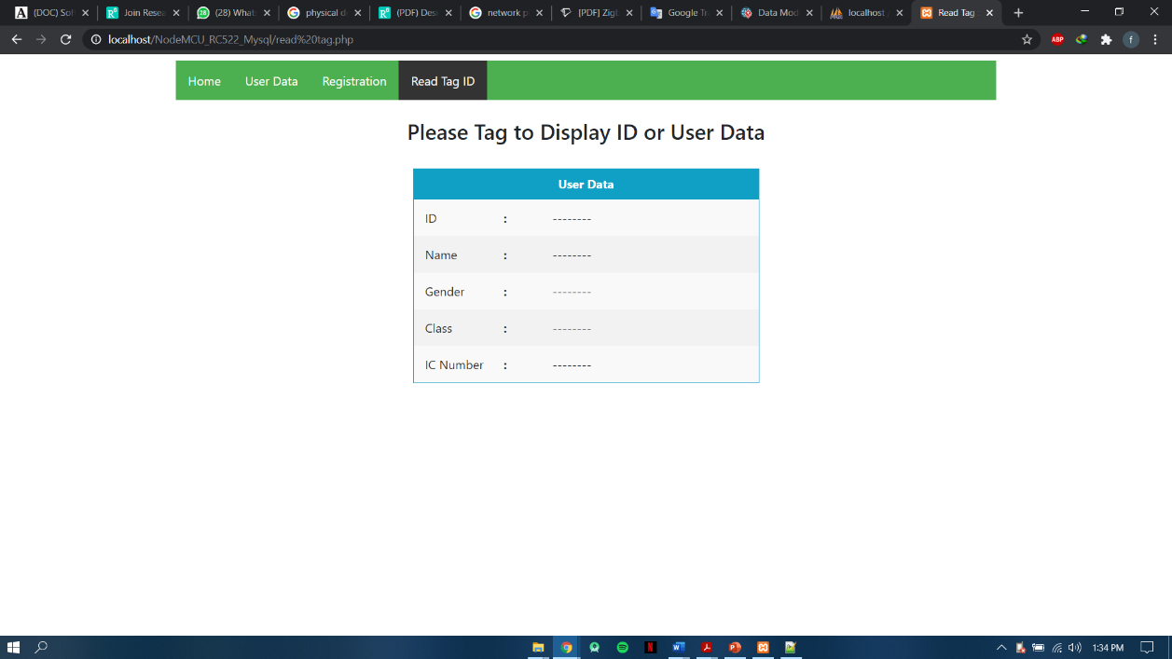

**CHAPTER 4**

**4.0 TEST DESCRIPTION AND RESULT**

**4.1 Unit Testing Plan**

|  |  |  |  |  |  |  |
| --- | --- | --- | --- | --- | --- | --- |
| **No.** | **Test Case Name** | **Test Procedure** | **Pre-**  **Condition** | **Expected Result** | **Tester** | **Result(Pass**  **/Failure)** |
| 1 | Login | User is required to fill the username and password field before access the system. | Username and password are set already in system without registration | +ve case Prompt successful register  -ve username and password does not match | Annoor | Pass |
| 2 | Logout | User logout from the system by clicking logout button | None | +ve case Prompt login page | Zihny | pass |

Table 4.1 Web System Unit Testing Plan (UTP)

|  |  |  |  |  |  |  |
| --- | --- | --- | --- | --- | --- | --- |
| **No.** | **Test Case Name** | **Test Procedure** | **Pre-**  **Condition** | **Expected Result** | **Tester** | **Result(Pass**  **/Failure)** |
| 1 | Scan RFID tag/card | User touch their RFID tag/card at the scanner | The Student Information are set already in system if their is valid user and had registered. | +ve case  Successfully  Read data and save record attendance in database. | An noor | pass |
| 2 | Get daily student attendance record | Teacher can export daily student attendance record from web application | None | +ve case  Successful export to excel | Zihny | pass |

Table 4.2 School Attendance System using RFID Unit Testing Plan (UTP)

**4.2 Integration Testing Plan**

|  |  |  |  |  |  |  |
| --- | --- | --- | --- | --- | --- | --- |
| **No.** | **Test Case Name** | **Test Procedure** | **Pre-**  **Condition** | **Expected Result** | **Tester** | **Result(Pass**  **/Failure)** |
| 1 | Login | User is required to fill the username and password field before access the system. | Username and password are set already in system without registration | User will directly go to the homepage system after login | Annoor | Pass |
| 2 | Logout | User logout from the system by clicking logout button | None | User will directly go to login page after clicking button sign out | Zihny | pass |

Table 4.3 Web System Integration Testing Plan (ITP)

|  |  |  |  |  |  |  |
| --- | --- | --- | --- | --- | --- | --- |
| **No.** | **Test Case Name** | **Test Procedure** | **Pre-**  **Condition** | **Expected Result** | **Tester** | **Result (Pass**  **/Failure)** |
| 1 | Scan RFID tag/card | User touch their RFID tag/card at the scanner | The Student Information are set already in system if their is valid user and had registered. | +ve case  Successfully  Read data and record attendance and display in web application | An noor | pass |
| 2 | Get daily student attendance record | Teacher can export daily student attendance record from web application | None | +ve case  Successful export to excel | Zihny | pass |

Table 4.4 School Attendance System Integration Testing Plan (ITP)

**5.1 Advantage of the Project**

1. RFID-based attendance system is able to track the attendance accurately as each RFID tag is unique.

2. RFID-based attendance system is able to shorten the time compared to the current method which records the student attendance manually.

3. System to make it easier for teachers to record and view daily student attendance for more systematically from the web application.

4. Store all information in database safely.

**5.2 Limitation of the Project**

1.Security is an important issue in RFID based system. Anyone can use others RFID tag, so it will hamper in our security.

2.Time consuming is also an important issue. When start class time and all students come in front of the class and they attach student id card in RFID reader one by one that’s take more time.

3.RFID is expensive than barcode system.

4.Liquid and metal things reflect when it comes near the RFID reader and then data is unreadable.

There is some limitation in RFID system. There is also an issue of security system. Therefore, that is why in future we can work on it. That no one can hack the system or no one can give proxy of other. Therefore, we will work on this in future. For future work, we think something on our project.

**CHAPTER 6**

**6.0 CONCLUSIONS**

Design and development of School Attendance System using RFID is one of best way to take attendance of the student. New Technology’s modern invention in the monitoring system that provides more advantageous way and will be a massive success in improving the current traditional way of monitoring students.

The Institution Management faces many challenges like student missing, student bunking class, faculty marking fake attendance, faculty spending 30% time on Error manual Attendance, lack or no communication among students, Admin staffs. So all these things solved by Smart Attendance System using RFID. These RFID can detect student entry mark their attendance within 1 minute and sent notification to the teacher and student whole information will kept in database server.

**CHAPTER 7**

**REFERENCES**

|  |  |
| --- | --- |
| [1] | Anshulpareek, "Arduino Project Hub," [Online]. Available: https://create.arduino.cc/projecthub/gadgetprogrammers/version-2-0-advanced-attendance-system-without-ethernet-0402ba?ref=similar&ref_id=151659&offset=4. |
| [2] | Mxtronixtech. [Online]. Available: https://www.projectsof8051.com/rfid-based-attendance-management-system/. |
| [3] | A. V. Konni, "Instructables Circuits," [Online]. Available: https://www.instructables.com/id/Automatic-Students-Attendance-System-Using-Arduino/. |
| [4] | I. D. PRO. [Online]. Available: https://iotdesignpro.com/projects/arduino-rfid-based-attendance-system. |
| [5] | M. Alam, "Electronics how to!," [Online]. Available: https://how2electronics.com/iot-rfid-attendance-system-arduino-esp8266/. |
| [6] | Pratikdd, "Slide Share," [Online]. Available: https://www.slideshare.net/Pratikdd/smart-attendance-system-using-rfid. |
| [7] | J. Paredes, "Arduino Project Hub," [Online]. Available: https://create.arduino.cc/projecthub/jeffpar0721/add-wifi-to-arduino-uno-663b9e?ref=platform&ref_id=424_trending___&offset=8. |